**dmcb Zombieland CTF**

Remember Rule Number 1: No patching

So now that we have the rules out of the way, lets begin! Firstly, the challenge of not jumping ahead was my first barrier, because the 7zip file is password protected and I didn’t read through completely to see the **bold** writing… Once this first hurdle was completed, I set about running the application like normal to see what I expect to see normal functions to be, and to my surprise, it acts a little like a text based game!

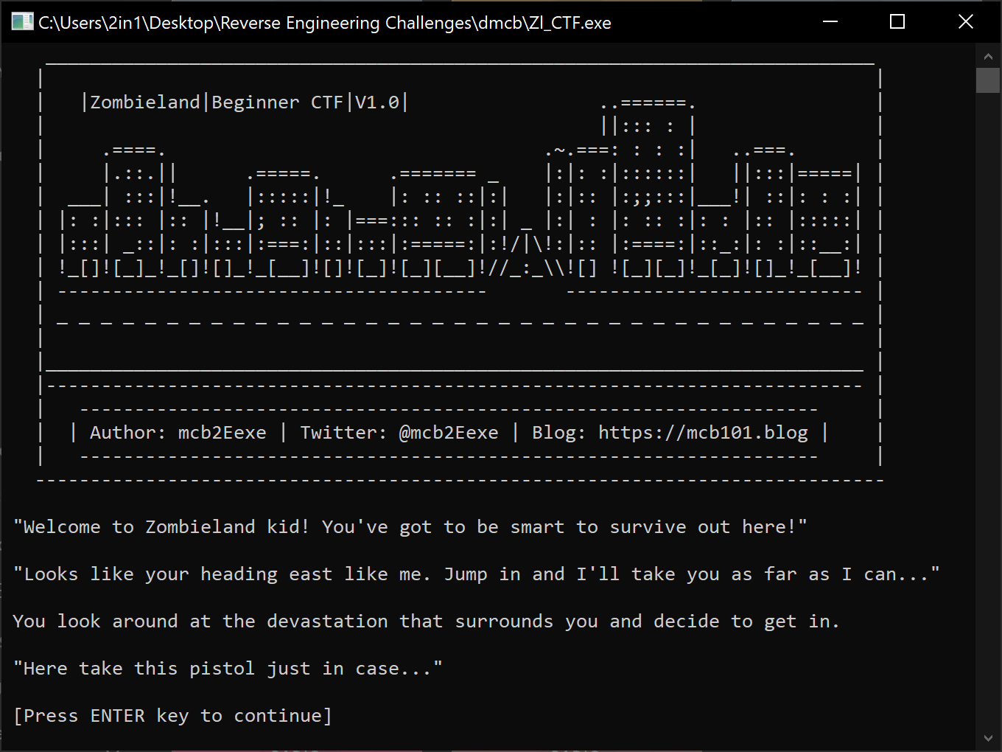Moving forward, we are presented with our first True/False check over, you guessed it, a Twinkie.

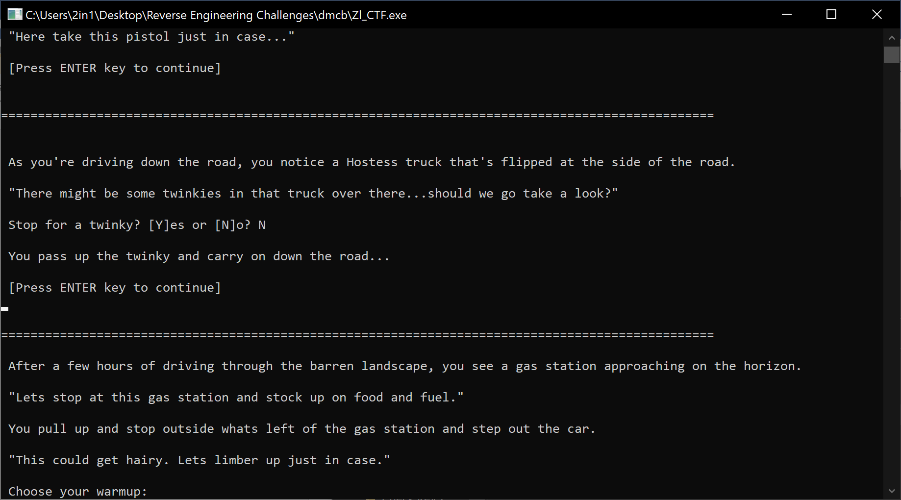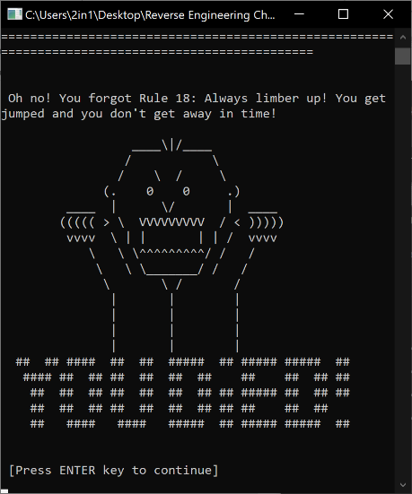Question is, do we stop or not? Well if you do stop, you are faced with finding snowballs and therefore death, so we need to say N [no] to stopping, to continue our journey;

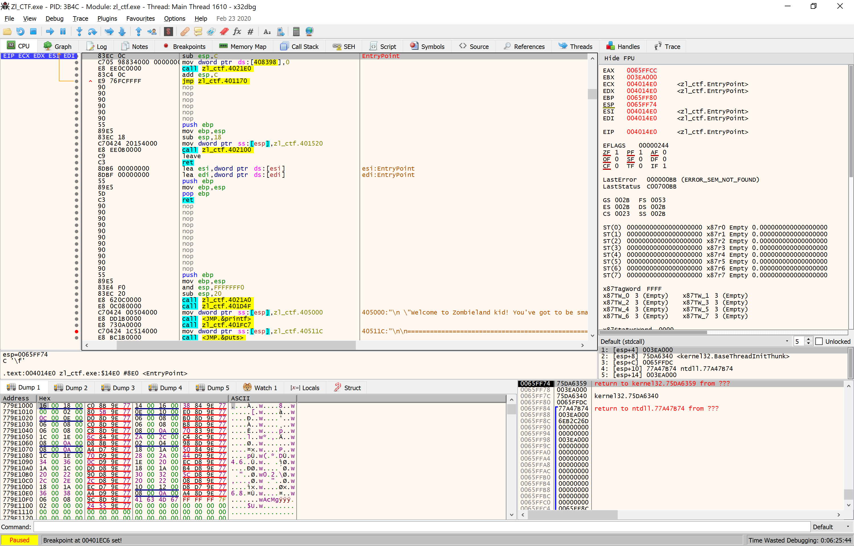Now, upon trying a variety of warmups, you will continuously be caught by one of those pesky undeads, which means we now need to open up our trusty debugger to find out what’s going on, and how we can workout, our workout… Running x32dbg up to the entry point we are met with some interesting strings at the bottom of the disassembler;

Let’s look at those strings somewhat closer, and see what’s going on... Setting a breakpoint on the first function <mov dword ptr:ss[esp].XXX.405000> and running the code will run all the background code that we aren’t too concerned about currently, because we know the code we want to interrogate is past the welcome screen. Typing graph here, will show us that we have a few barriers to jump through, or we die (brainzzzzz)

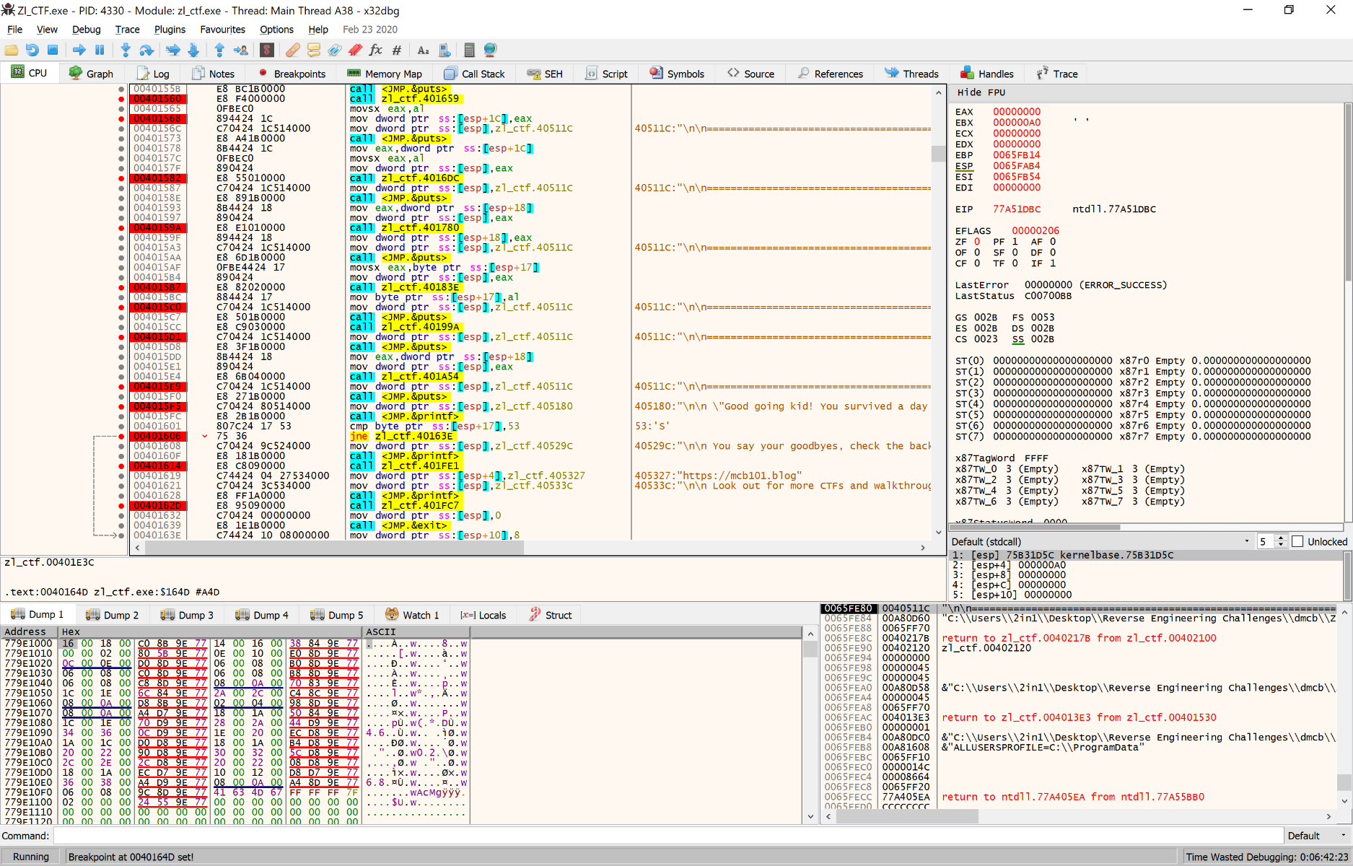What we do now, is set a breakpoint on the calls after these long strings. They are clearly something useful that will aide us in finding the correct guesses from now on. Address 0040154F is our introduction, 00401560 is our first hurdle, which is know from trying the program originally, is our Twinkie check;

From now, we are going to use the step into function from each of these breakpoints to see what happens when the code runs, and what we can do to get through the application. Following into the program, we see that it prints our Warmup check, moves a ‘%s’ into memory, then string compares the users input against the valid warmup, and either stating we’re ready for anything, or death;

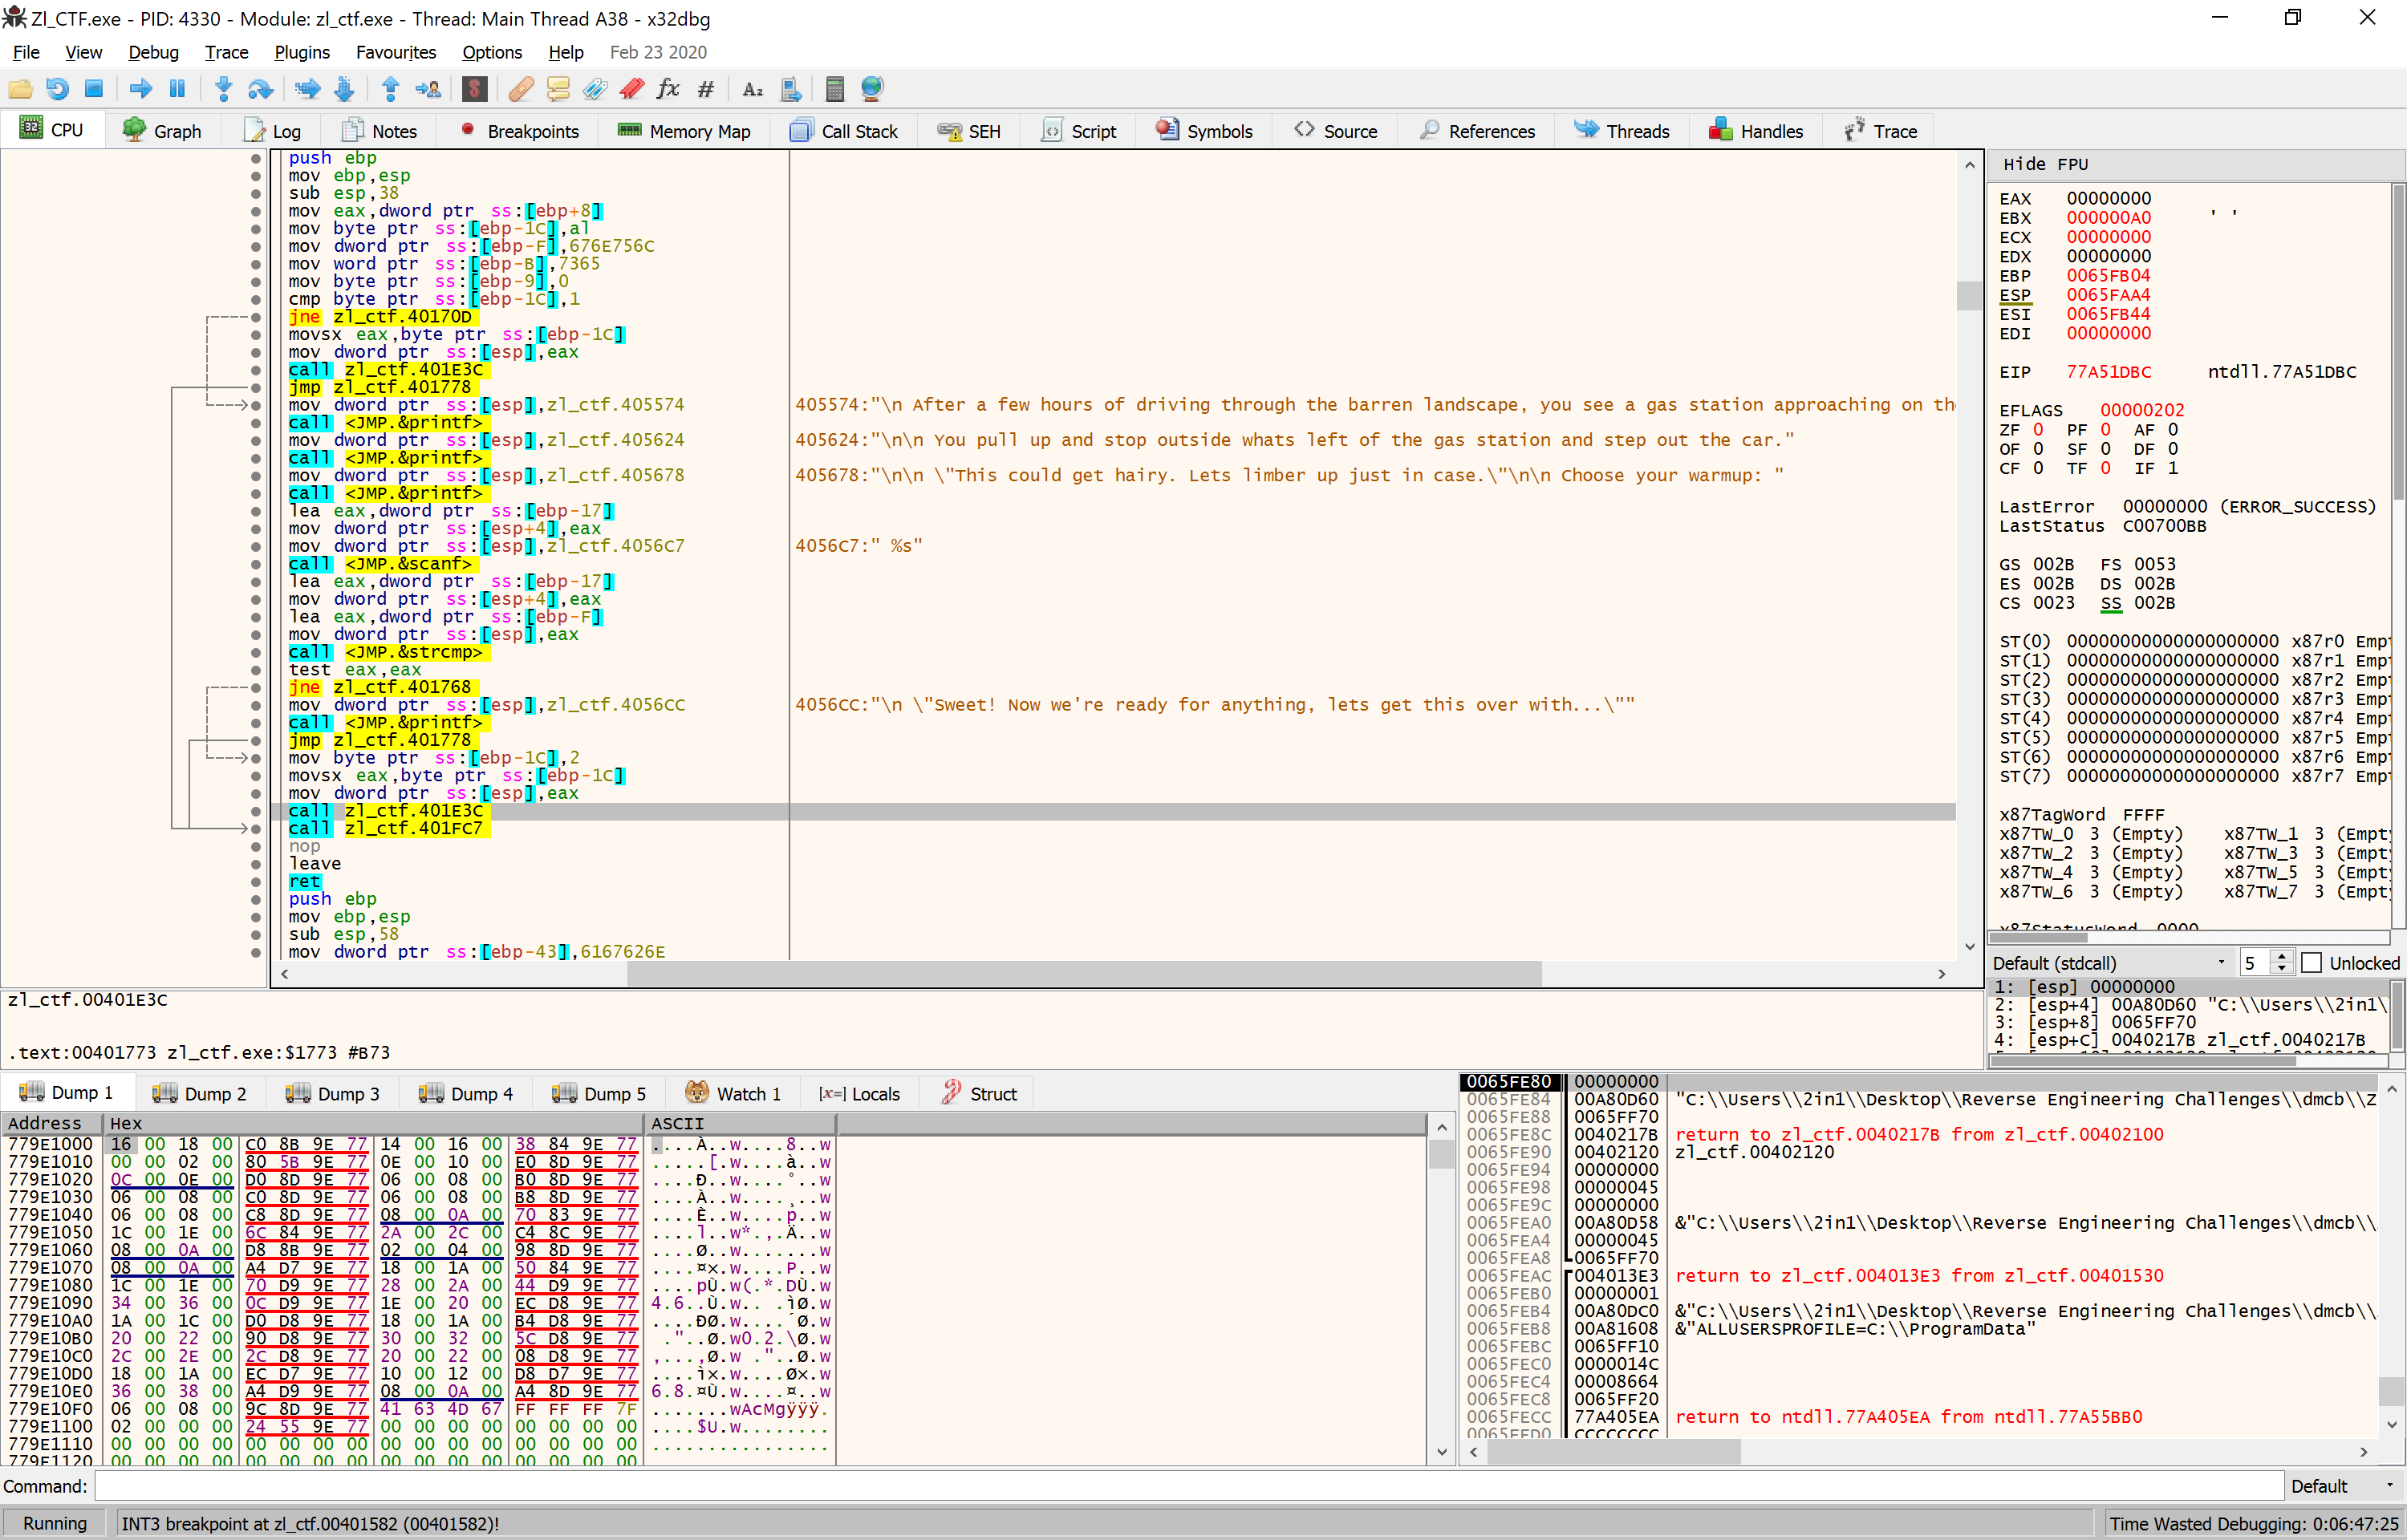

Clearly then, we need to look at the data that’s moved from XXX.4056C7 into the stack so we can use it for our own bidding rather than discovering that ‘stretching’ was not a valid guess (I may have watched the film) To do this, we look at the data side of the screen that shows the changes each cycle. Each time the cycle runs, the data is changed, helping the user to see what that cycle command has done. Setting a breakpoint above and on the command is something I personally finds help me, in case I accidently double click, but to also allow me to see a command beforehand to see what’s changed. This can clearly be adjusted/removed per user operation. We also set a breakpoint on the jmp.strcmp which compares our input to the programmers acceptable input…

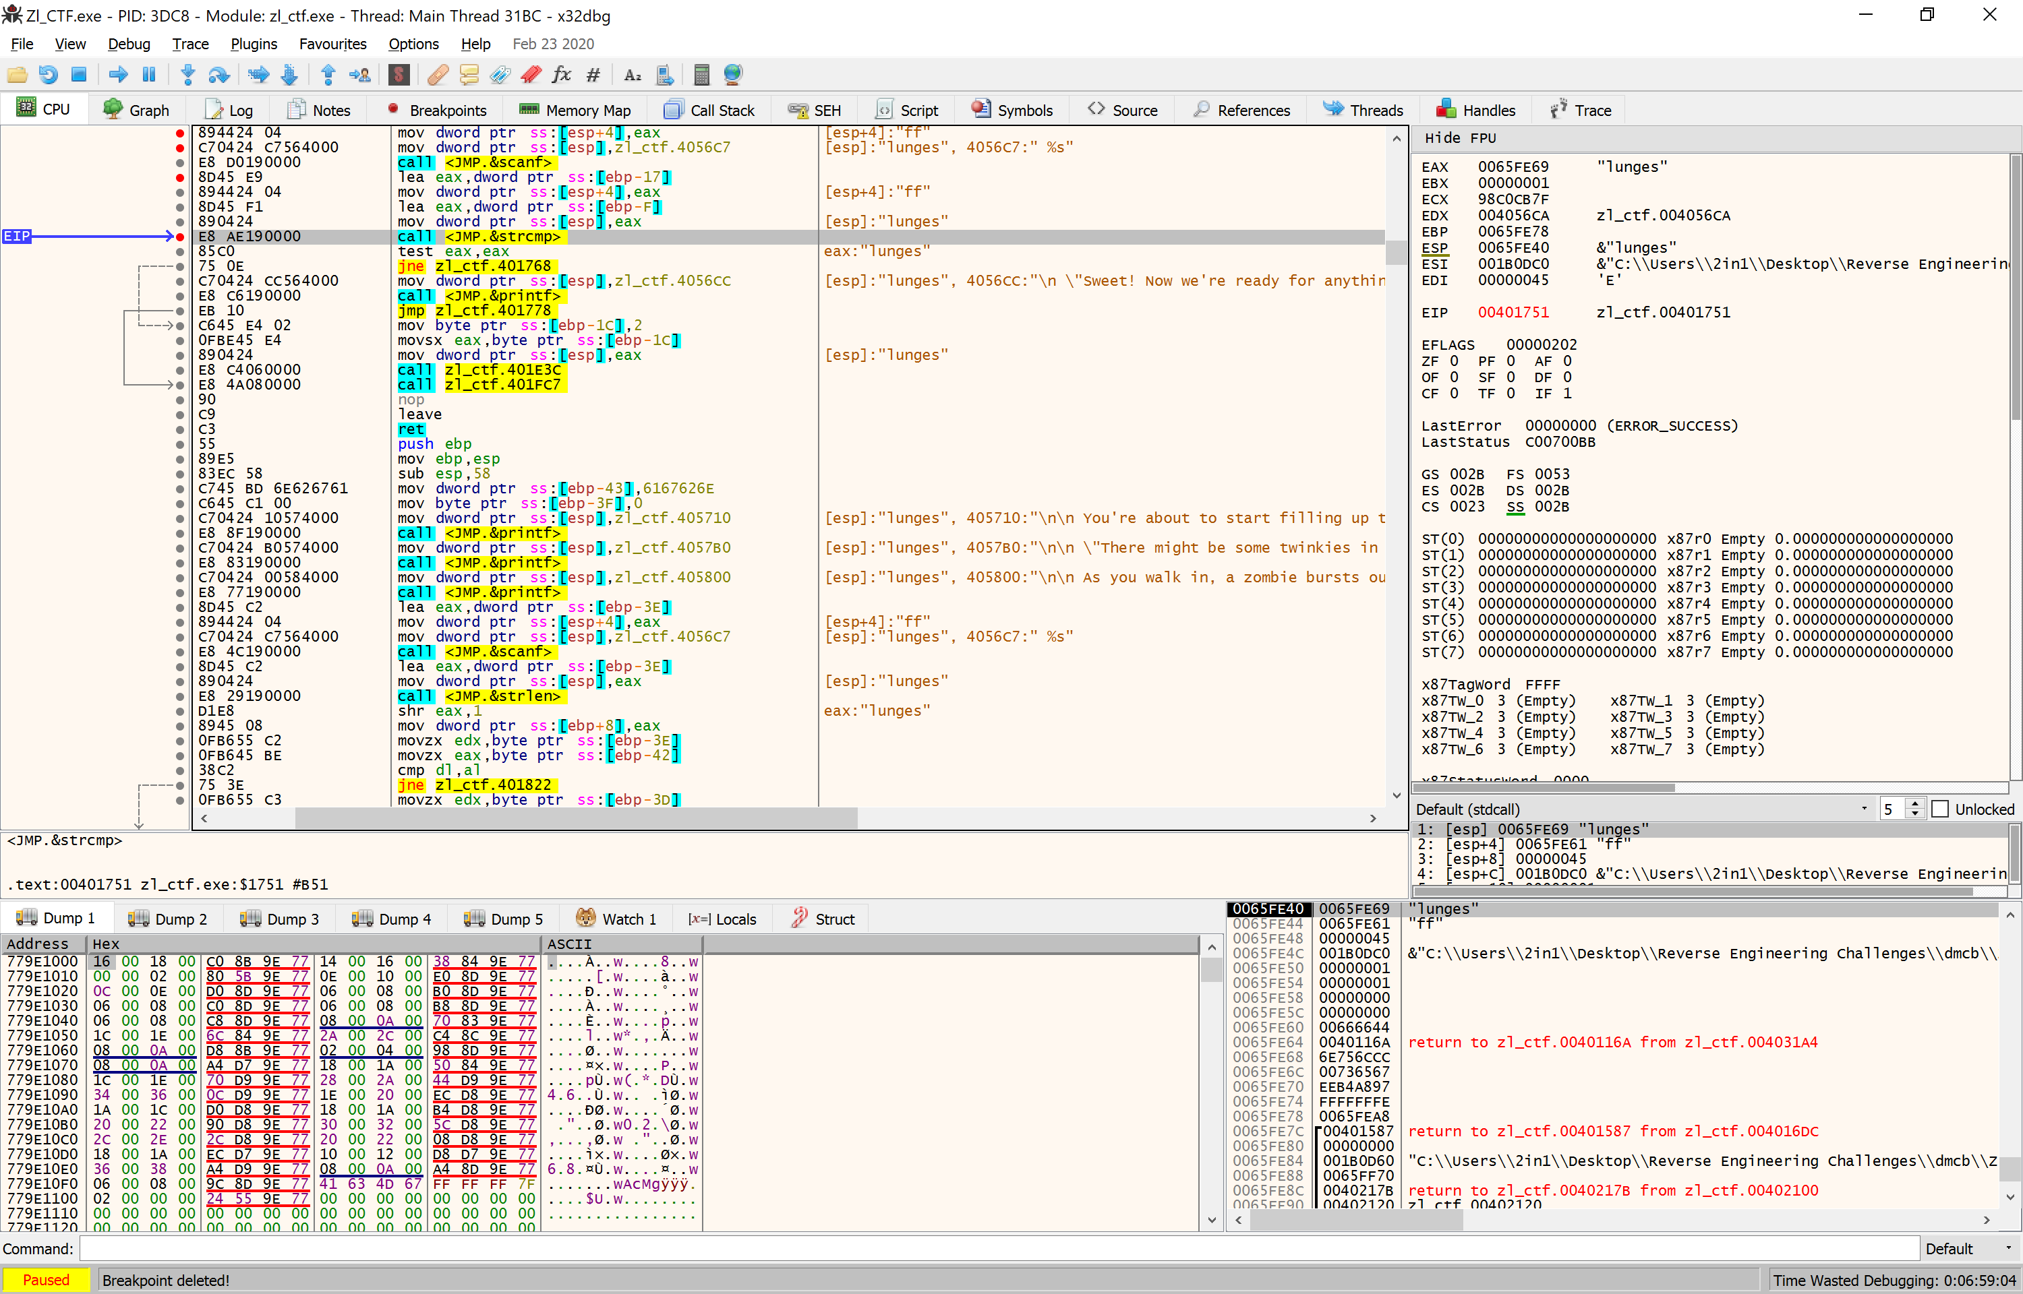

Now for a very quick debugging lesson. If we look the 4 commands between scanf and strcmp, we see there are 2 memory loads, and 2 data moves. This means that the input from the user is loaded, then the actual key is loaded, then compared. If it’s correct, then it loads “Sweet!....” otherwise, you guessed it, death. A simple cake or death scenario.

With this example, we can see that I typed in ff as a guess, which reaffirms my statement of loading user input first, then loading the internal programs key which we can see in the 2 highlighted places below turns out to be… lunges … Ok, it’s been a while since I’ve seen the film, but stretches wasn’t a bad guess!



After reloading the debugger, we can now continue past our breakpoints, type in lunges, and then continue with our journey. You can also use a second, undebugged running version too, which will help keep track of where you are and the correct guesses if you aren’t taking notes..

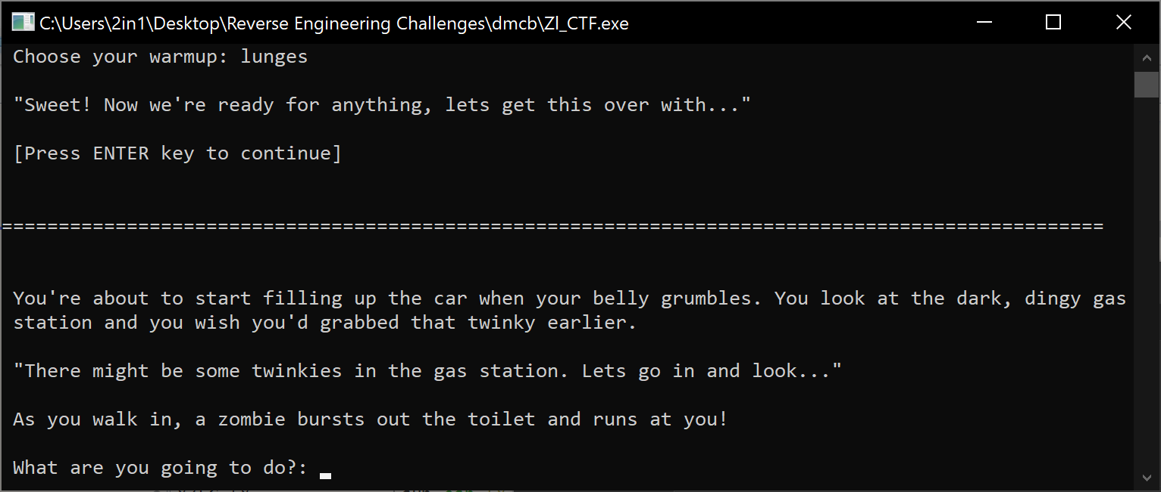

Everyone knows the zombies always follow you into the toilets. Anyway, much like before, we jump to the next breakpoint that we previously set, and see what the code runs by stepping into the call. What we see this time is a string compare but also a bit shift right, by 1 bit. Interesting!

Knowing that we don’t have the key, I typed anything action related, push. After setting the breakpoints on all of the compare 2 different memory regions, we can read the memory as it’s being compared and see what we should have, I hope…

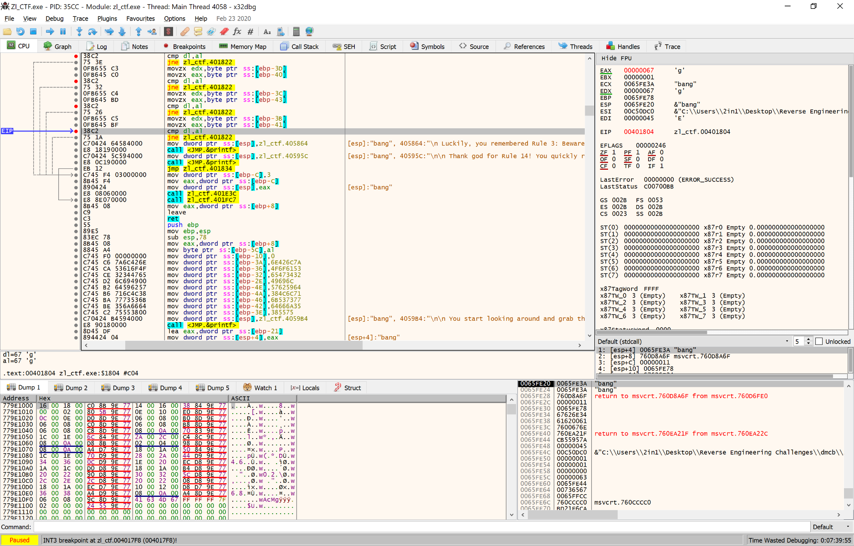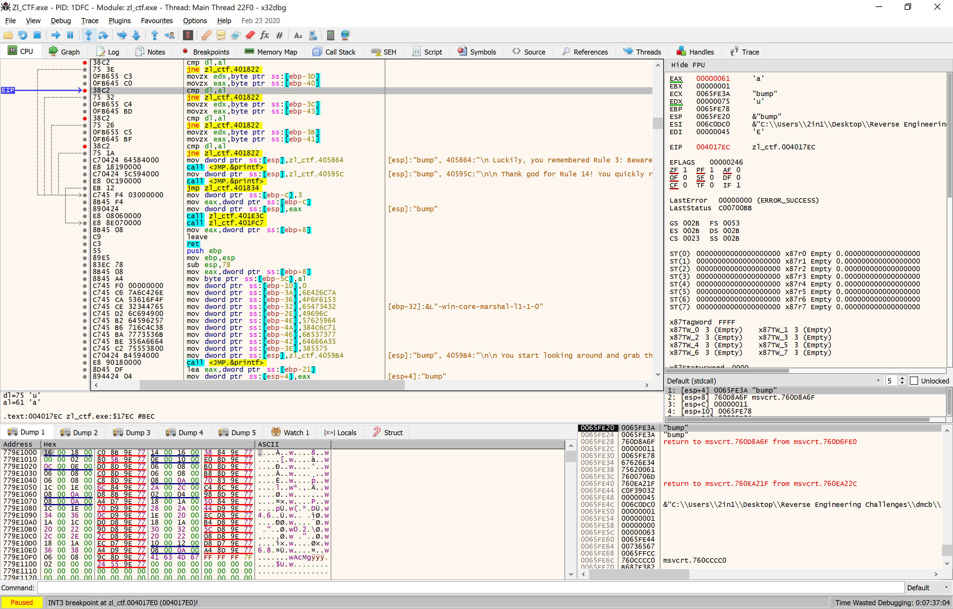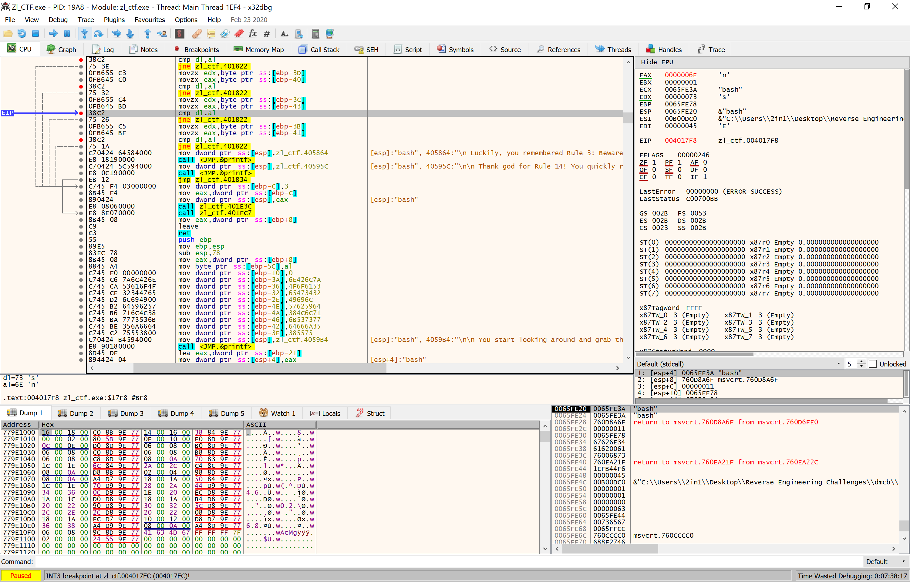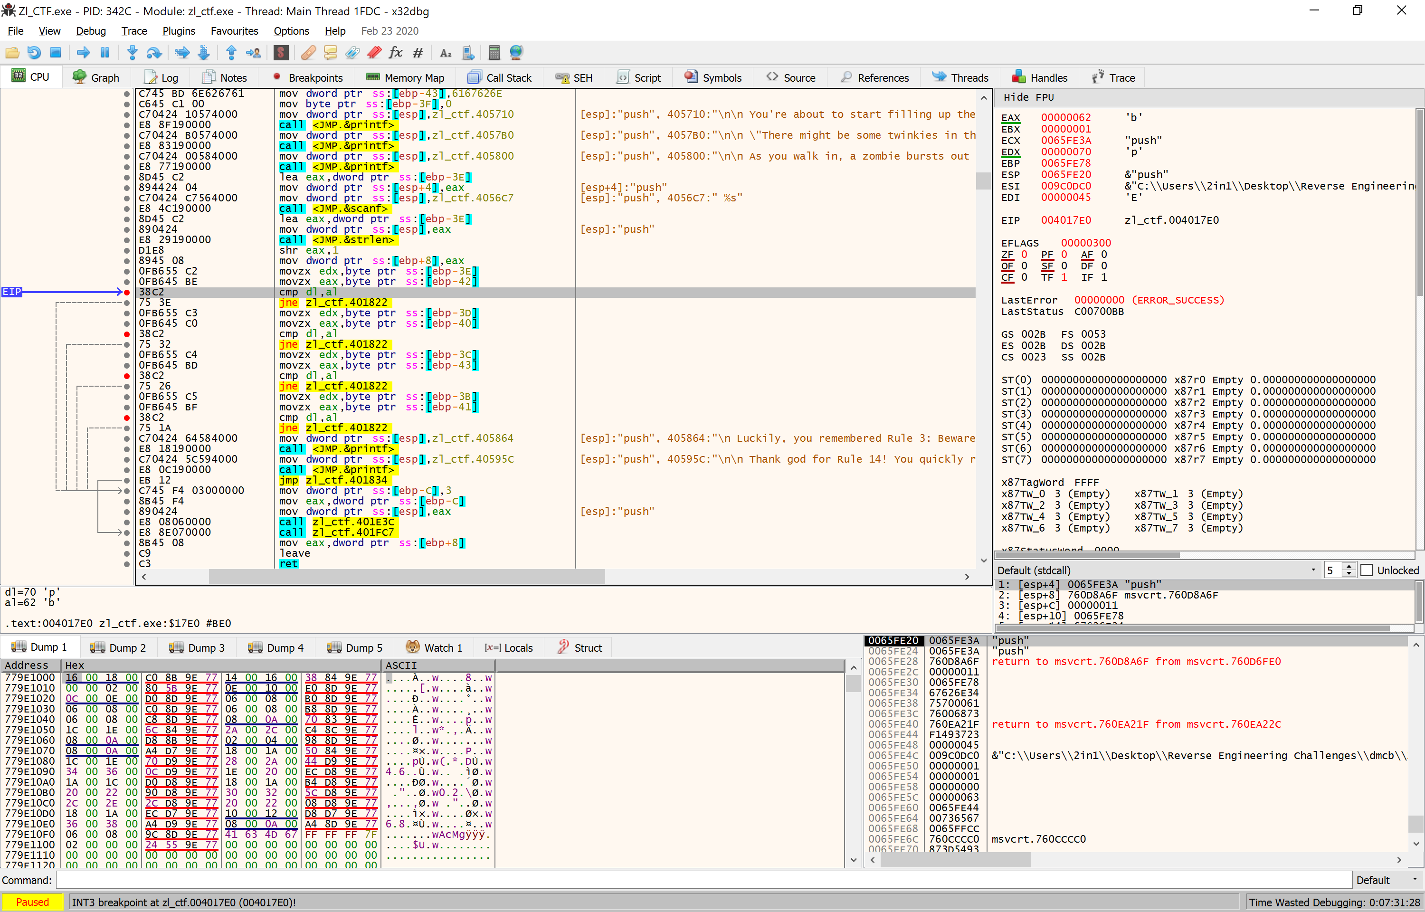So, on running, we can see the Action check key per character of the key against the programmers internal code. Thankfully it’s also not encrypted! If we look at the EAX and EDX registers (in green) we can see that the AL register (part of EAX) is expecting ‘b’, whereas the DL register (part of EDX) is p from my guess at push… So, while this isn’t the most glamorous of solutions, if we run this 4 times (4 compares) then we can get the code… Otherwise it’s cake or death again!

After my third guess, I got the correct code as ‘bang’ and then are met with our next code, Grab check. Following the code, breakpoints and all, we are met with a large amount of data being moved, and a string length check. Lets see what we get running through each data transfer.

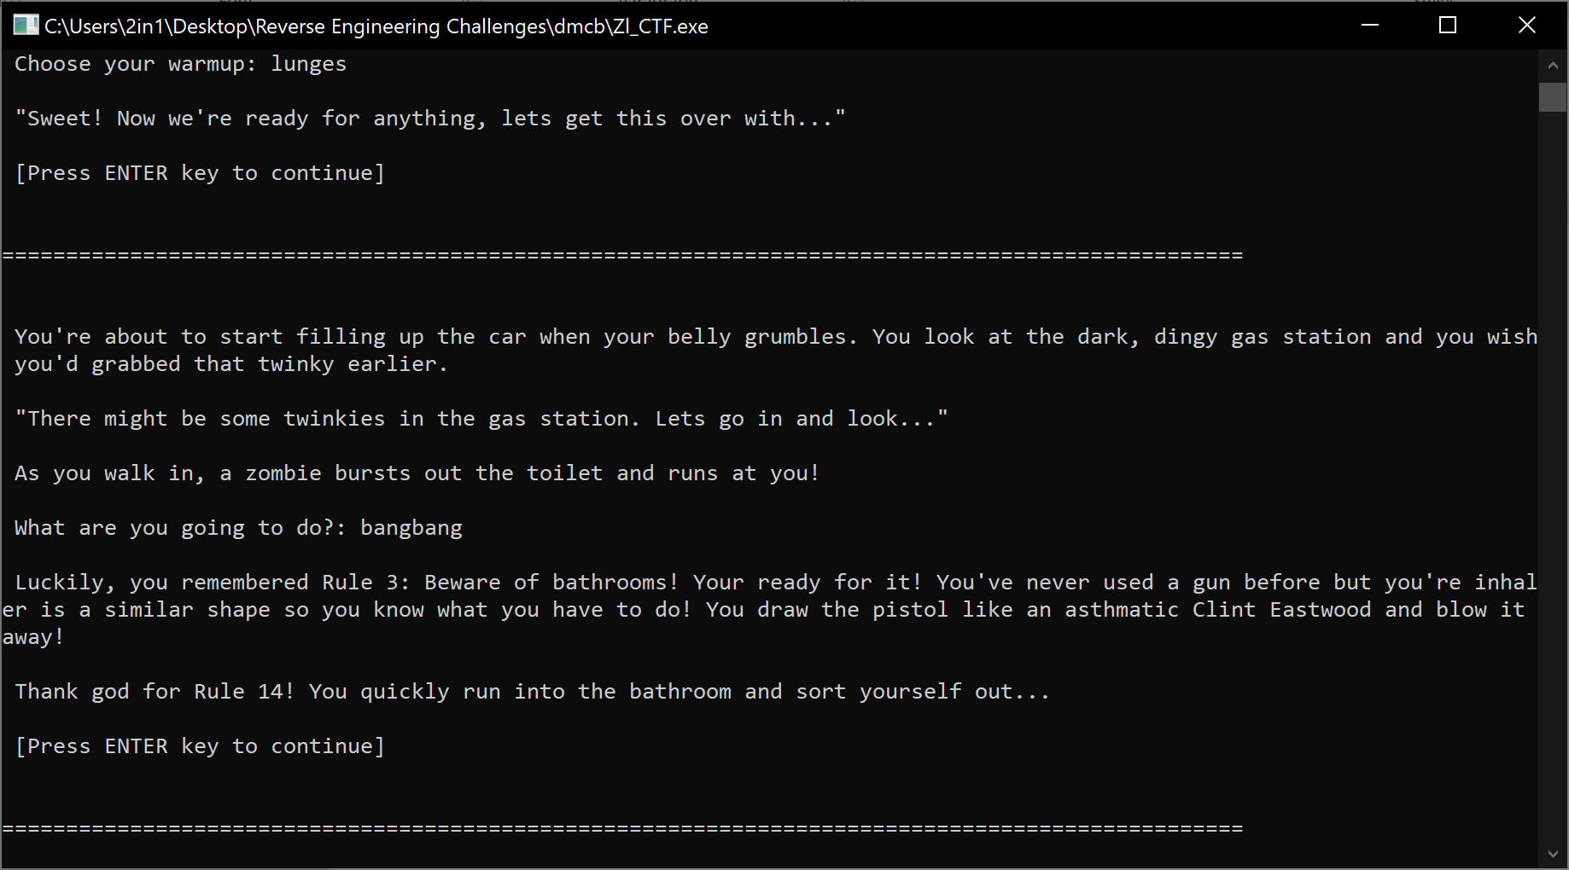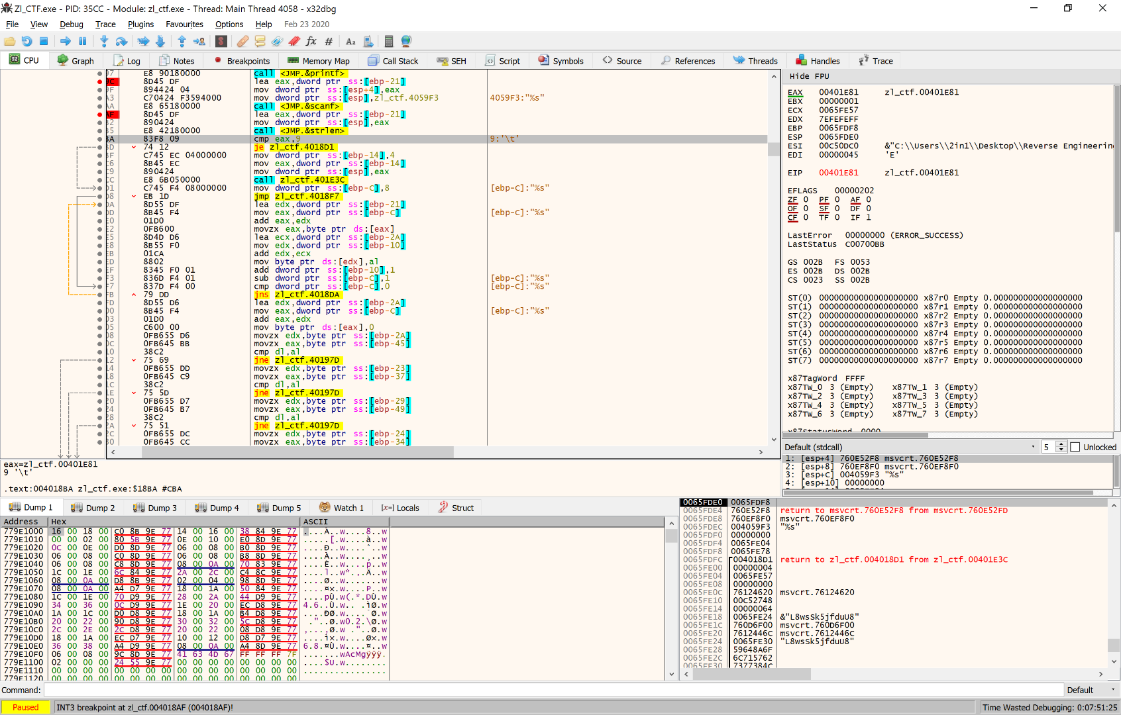

So our next challenge, we are faced with working out what weapon we are going to use against that pesky zombie that nearly catches us out! Naturally, I guess doorhandle, since we’re looking around and want to look in the room? Except we reach for the topshelf and attract an undead zed instead.

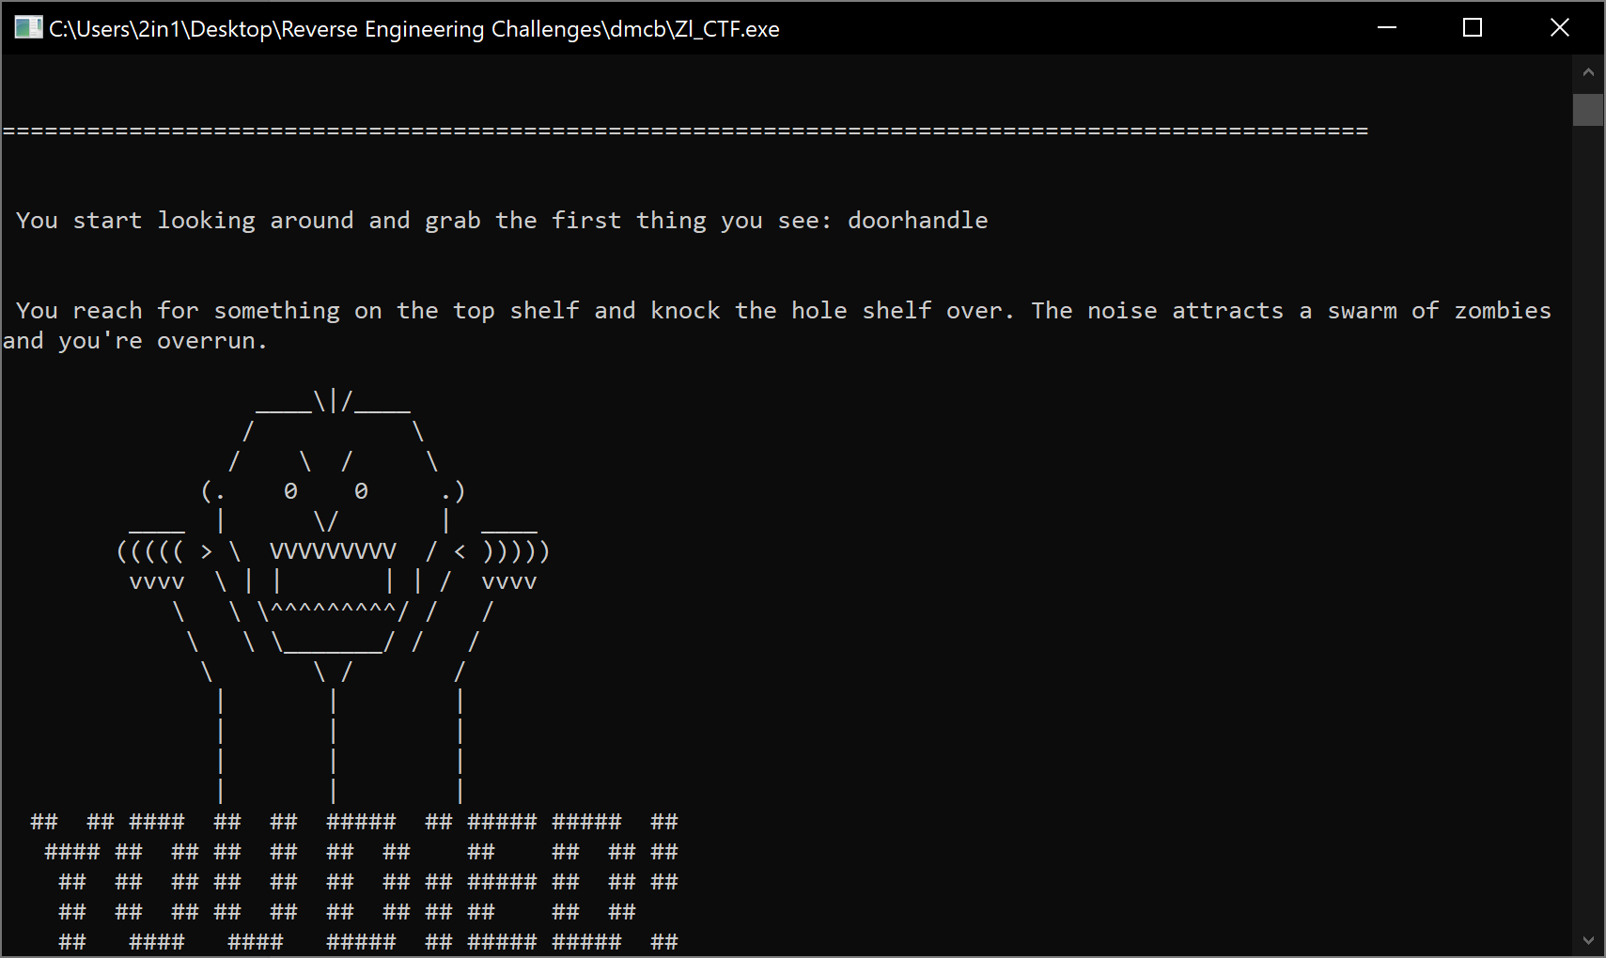

Well that didn’t work out, as the data that gets moved didn’t give us easy characters, and guessing leads us into a length check, leading us to cake or death. We need to get the correct amount of characters (9) to get around this hurdle, then see what the next code allows us to see. Upon typing binhandle (9 characters) the program now takes this, and strips each character down, changing it back to front then putting the original guess on the end… So my binhandle guess becomes eldnahnibbinhandle…

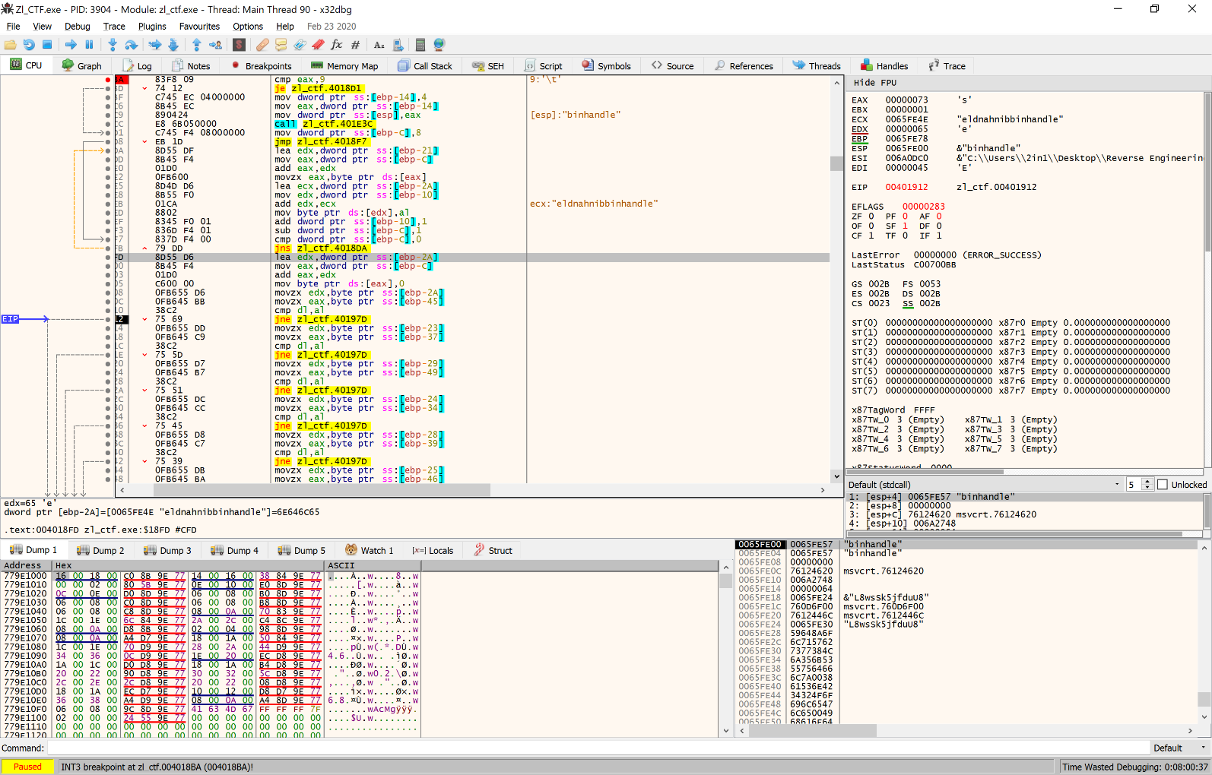

So to explain, the program takes the 9 characters of input, then continues into the loop (orange arrow on the left of the above picture) and puts it all back to front, with the original guess after the reversal. Thankfully however, the next check (small blue arrow) will still show us the expected memory, allowing us to run this over and over to get the password to our Action check… What we’re going to do this time, is follow the location of the checks [EBP-XX] in the dump, and decrypt the code on our first attempt, instead of running this 9 times!

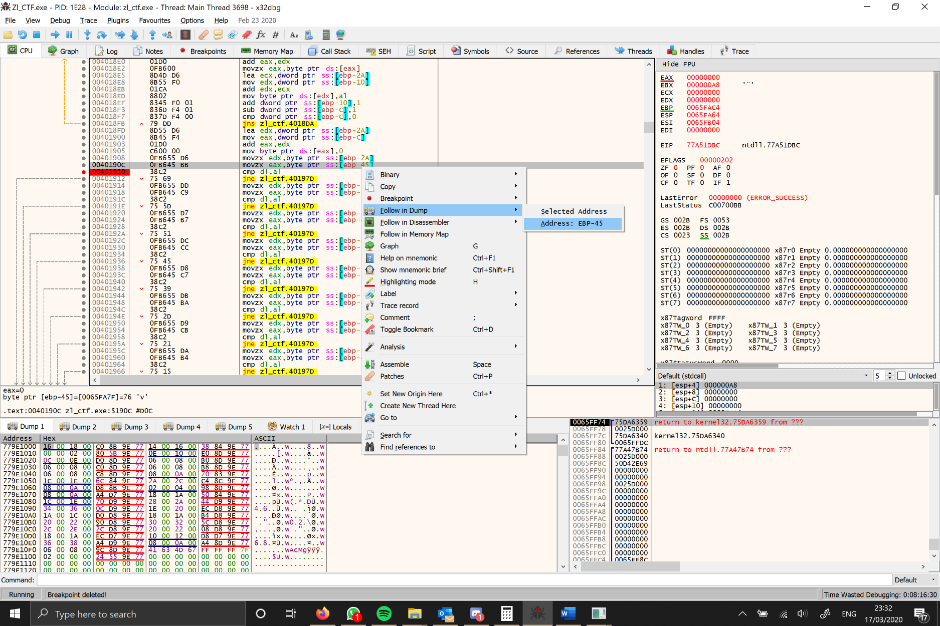After following the code, we end up with snlolwab. That’s not even a word! Well yes, but that’s because we’ve followed it if it were also reading the data in the order it’s being checked! So what we need to do is look at the order in which each code is checked and match it up, puzzle style…

Using the below table, we can see the checker looks for a 9 character word, and demangled is *nowballs. The * is the first character, but we aren’t checked on it… However, it’s safe to assume it’s snowballs…

|  |  |  |  |  |  |  |  |  |
| --- | --- | --- | --- | --- | --- | --- | --- | --- |
| E | i | L | N | D | H | N | A | B |
| 2A/45 | 23/37 | 29/49 | 24/34 | 28/39 | 25/46 | 27/35 | 26/4C | ?? |
| S | N | L | O | L | W | A | B | ?? |

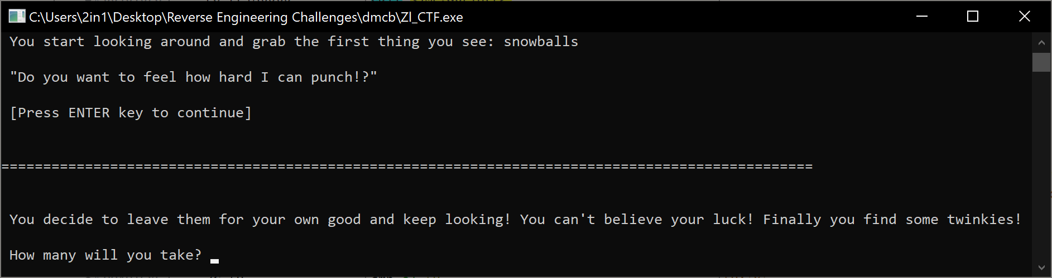Success! It was a good assumption… We are now onto our Take check;

This twinkie counter runs a loop 9 times, conducting a multiplication, incrementing the counter and checking whether it’s been ran 9 times. Further on, there’s 2 other compares against 2 and hex 5D (int 93). If we have a guess at numbers, we are met with finding the compare,2 command is checking that we are only taking 2 weapons, but we’re still trying to work out the sum of the twinkies.

After saying I’d take 100 Twinkies and 2 rifles, the sum (highlighted below) began to take effect. To put it simply, it begins by loading the loop counter, the original input (100 this time) then multiplying them together, adding the number of rifles you wanted to take and storing this figure into memory. The end result for me being 902, but we can see that there’s a compare of 2 and a compare of 5D (integer 93). 10 * 9, + 2 gives us 5C (92) and 11 gives us 65(101)… We’re missing something…

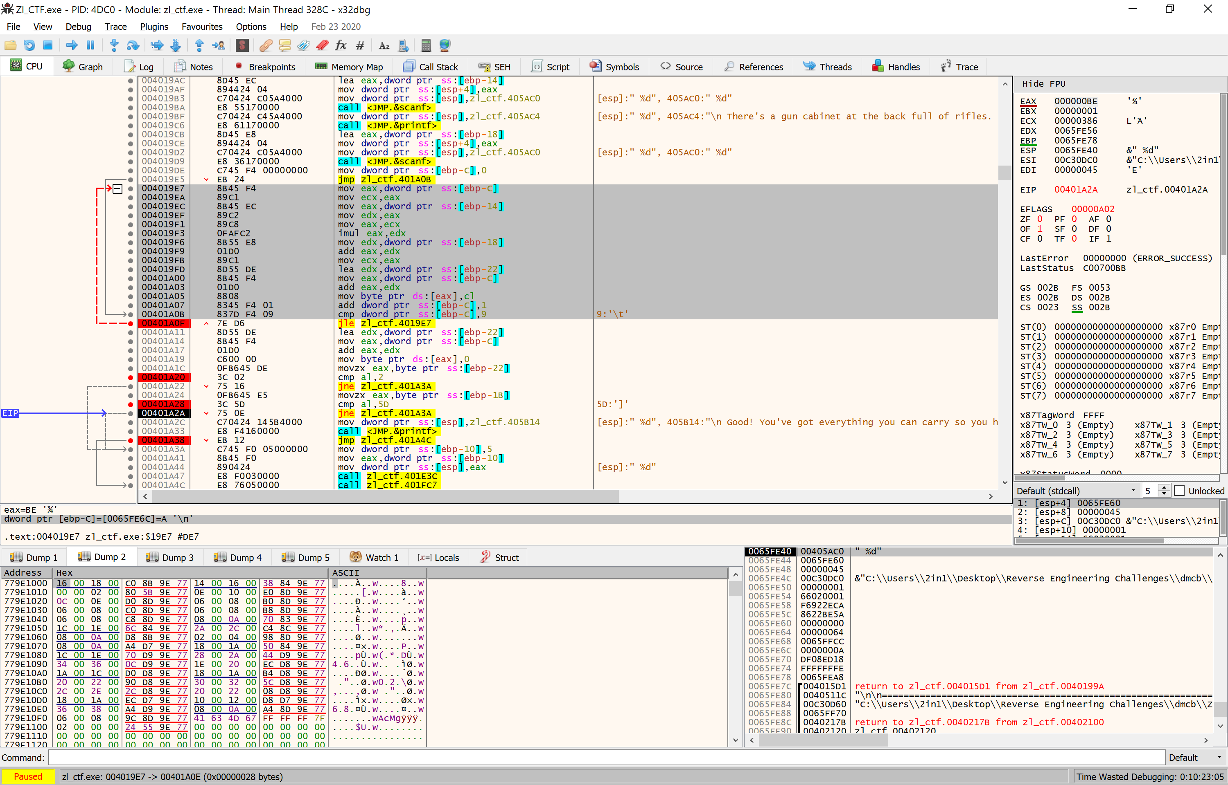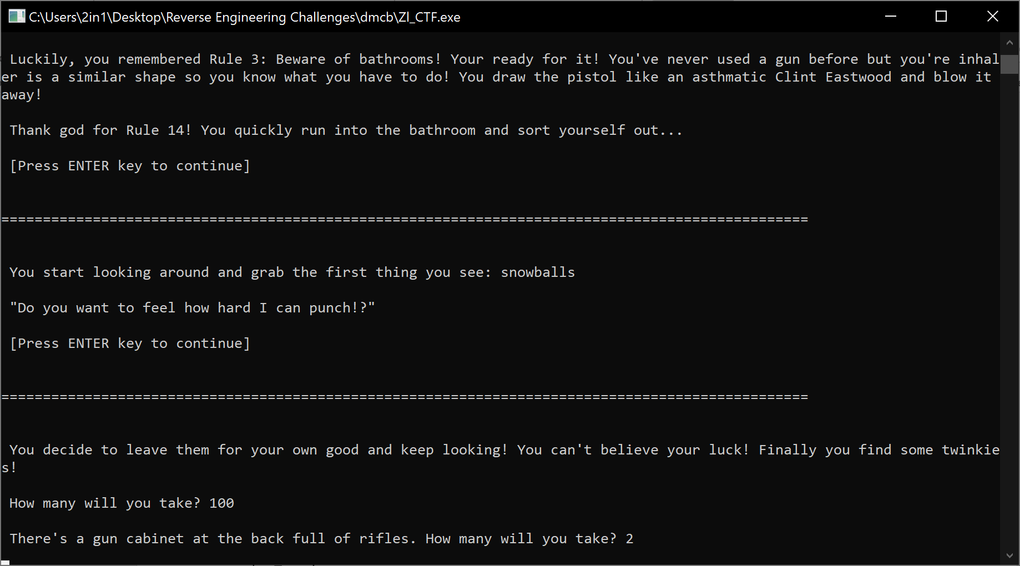

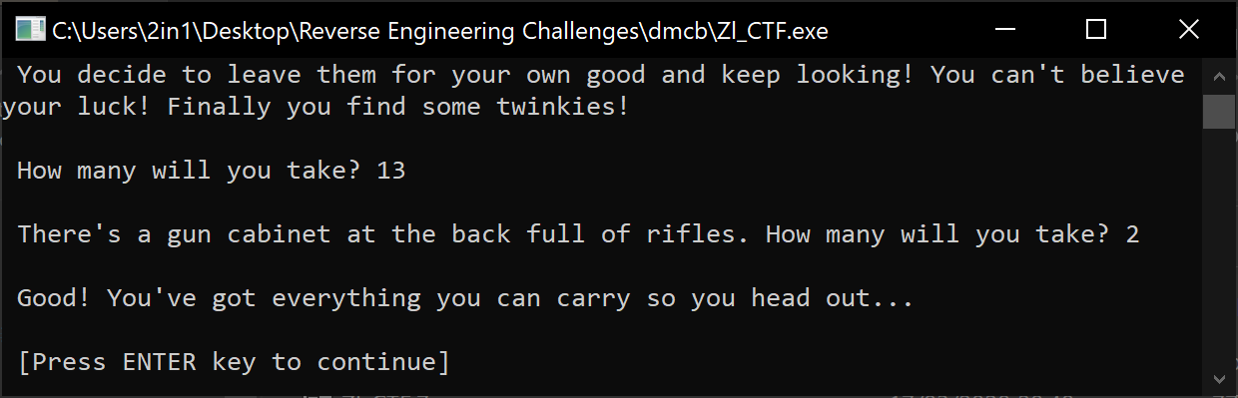Now I will admit I needed help here, but because I was thinking too small. When the program checks the area of memory, it’s checking the 7th iteration of the loop. I stumbled upon this after getting horrifically stuck and then realising that the increments of hex code, matched the calculations! We now know that the compare, 5D is actually X*7=93. Using a simple calculator, we can do 93/7 and get the magical number of 13!

However, we’re faced with a very unusual comment from here, that we’ve forgotten rule #2 about double tapping. The first issue, we have no input to look at! What we do have however is a clue about what we need to look into.

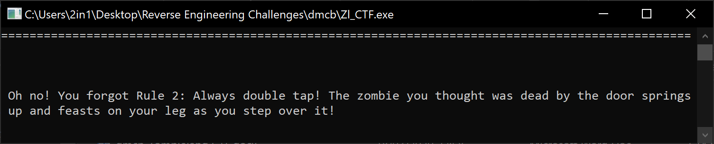

This to me says that we need to not only type bang, but rather bangbang (the hint of double tap!!) and success! It works!

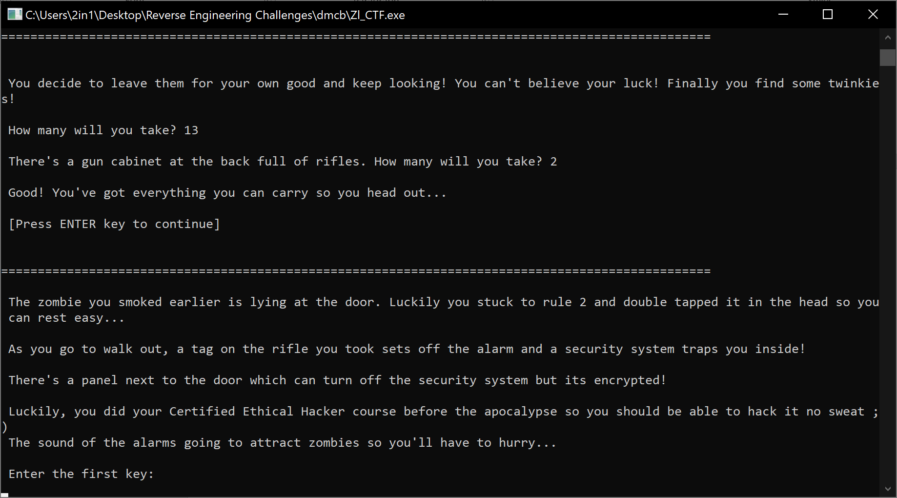

Interesting. Firstly, I don’t remember any hacking in the film, more pot luck shooting that naturally works in films and secondly, we need to hack this? Lucky we’re around then! Sadly however, we need to be swarmed at least once to find the key, so typing aaaaa I set about looking at the First Key challenge, and seeing what came about…

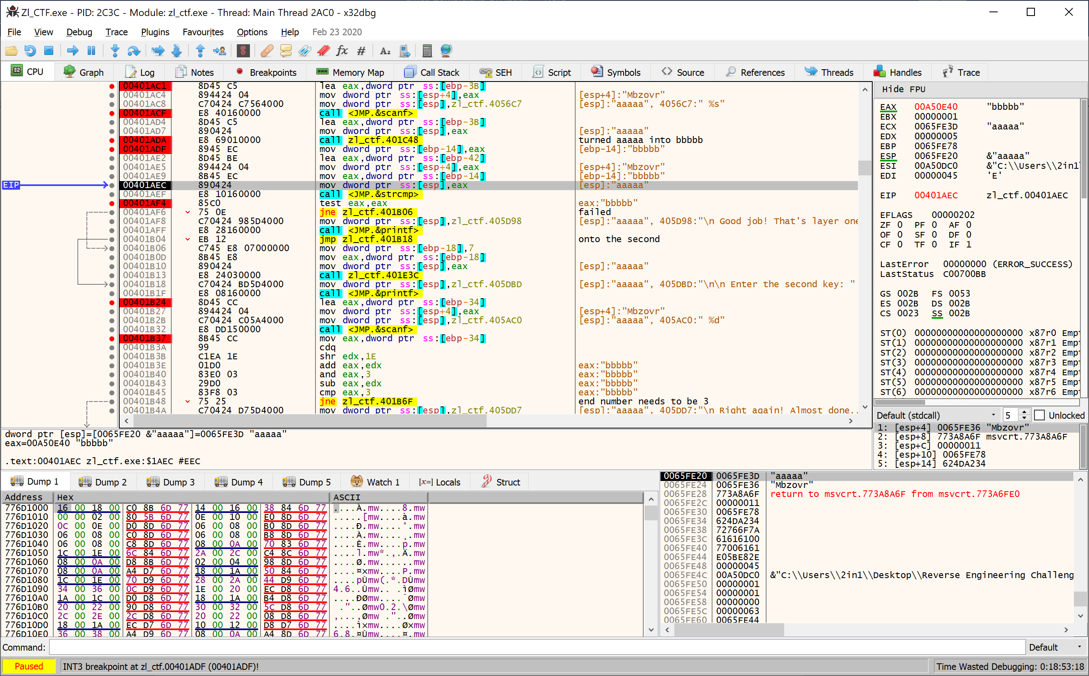

So setting all the excessive breakpoints, I finalised just before the test function looking at the data that was all over the screen. The call to 401C48 turned my input of aaaaa into bbbbb, which says to me that there is some addition going on within, but there’s a code completely unrelated labelled Mbzovr which must be the string compare code… So it’s not a simple up or down increment, thought our initial aaaaa went into bbbbb which probably meant something didn’t load correctly. With this, we know that the First Key requires at least 6 characters. After a couple rounds through the loop, you can see the pattern (though don’t understand the code that makes it happen) but if we take the characters of the input as a number, the pattern is as follows;

|  |  |  |  |  |  |
| --- | --- | --- | --- | --- | --- |
| 1st | 2nd | 3rd | 4th | 5th | 6th |
| +1 | -1 | -3 | +3 | +1 | +1 |

Translating that into hex, and applying the math from the Mbzovr that came around we end up with the following code to input; (Lc}luq)

|  |  |  |  |  |  |
| --- | --- | --- | --- | --- | --- |
| L | c | } | l (L lowercase) | u | q |
| M | b | z | o | v | r |

Except that didn’t work!! We did however get the ovr in the right places, which means I fluffed the calculation somewhere…

Looking online at how XOR works, I realised I wasn’t looking for a pattern, but instead should’ve been looking at bit math. Transcribing Mbzovr into bits, then XOR against the bit value of 3, and we’re then left with the following key (I just got incredibly lucky with the last 3 characters!!);

|  |  |  |  |  |  |  |
| --- | --- | --- | --- | --- | --- | --- |
| Key | **M** | **b** | **z** | **o** | **v** | **r** |
| Bits | 01001101 | 01100010 | 01111010 | 01101111 | 01110110 | 01110010 |
| XOR | **3** | **3** | **3** | **3** | **3** | **3** |
| Bits | 00000011 | 00000011 | 00000011 | 00000011 | 00000011 | 00000011 |
| XOR Bits | 01001110 | 01100001 | 01111001 | 01101100 | 01110101 | 01110001 |
| ASCII | N | a | y | l | u | q |

This allows us to crack on to the Second Key, at full speed whilst those undead zeds are trying to get to us and eat us…

Now I’m no genius, and hence why I’ve struggled with things and told you as such, however, this one didn’t take me long to work out because I just read the code, rather than trying to guess what tricks were being played…

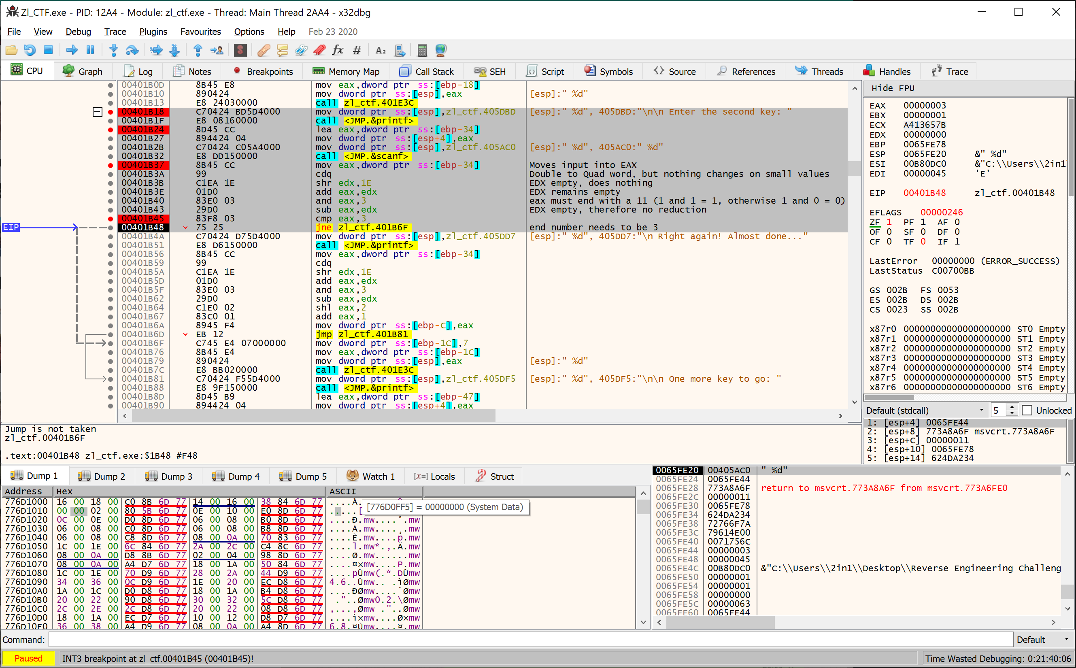

Looking over the comments I’ve placed, addr 401B18 calls the Enter the Second Key printout, and then addr 401B37 loads it into memory. From there, nothing much actually happens because no commands do anything to the EDX register, so we can effectively discount it. We have an and EAX, 3 meaning the bits in EAX needs to end with atleast 00000011 (aka decimal 3) therefore the easiest number is to use 3…

After running through to the One More challenge, I decided to look ahead a little before I tried my hand at this one, just because everything has been understood better as such, rather than running through and then wondering what happens… What I discovered was that the 3rd key had to be at least 4 characters long otherwise instant death, but there was also a string ‘obmg’ stored in the program that gets moved into memory, so I’m going to guess that’s the string comparison that the program wants us to end up with…

I used the input knowing full well that it was going to be rehashed into something else of nbch. While I didn’t get a result, I did find that the loop conducts a check of the loaded character of whether it is either an odd or an even number, and then subtracts if odd, or adds if even, hex code 0D (13) The following highlighted code is the loop in it’s entirety. Don’t take my notes as gospel, they might be slightly wrong however!

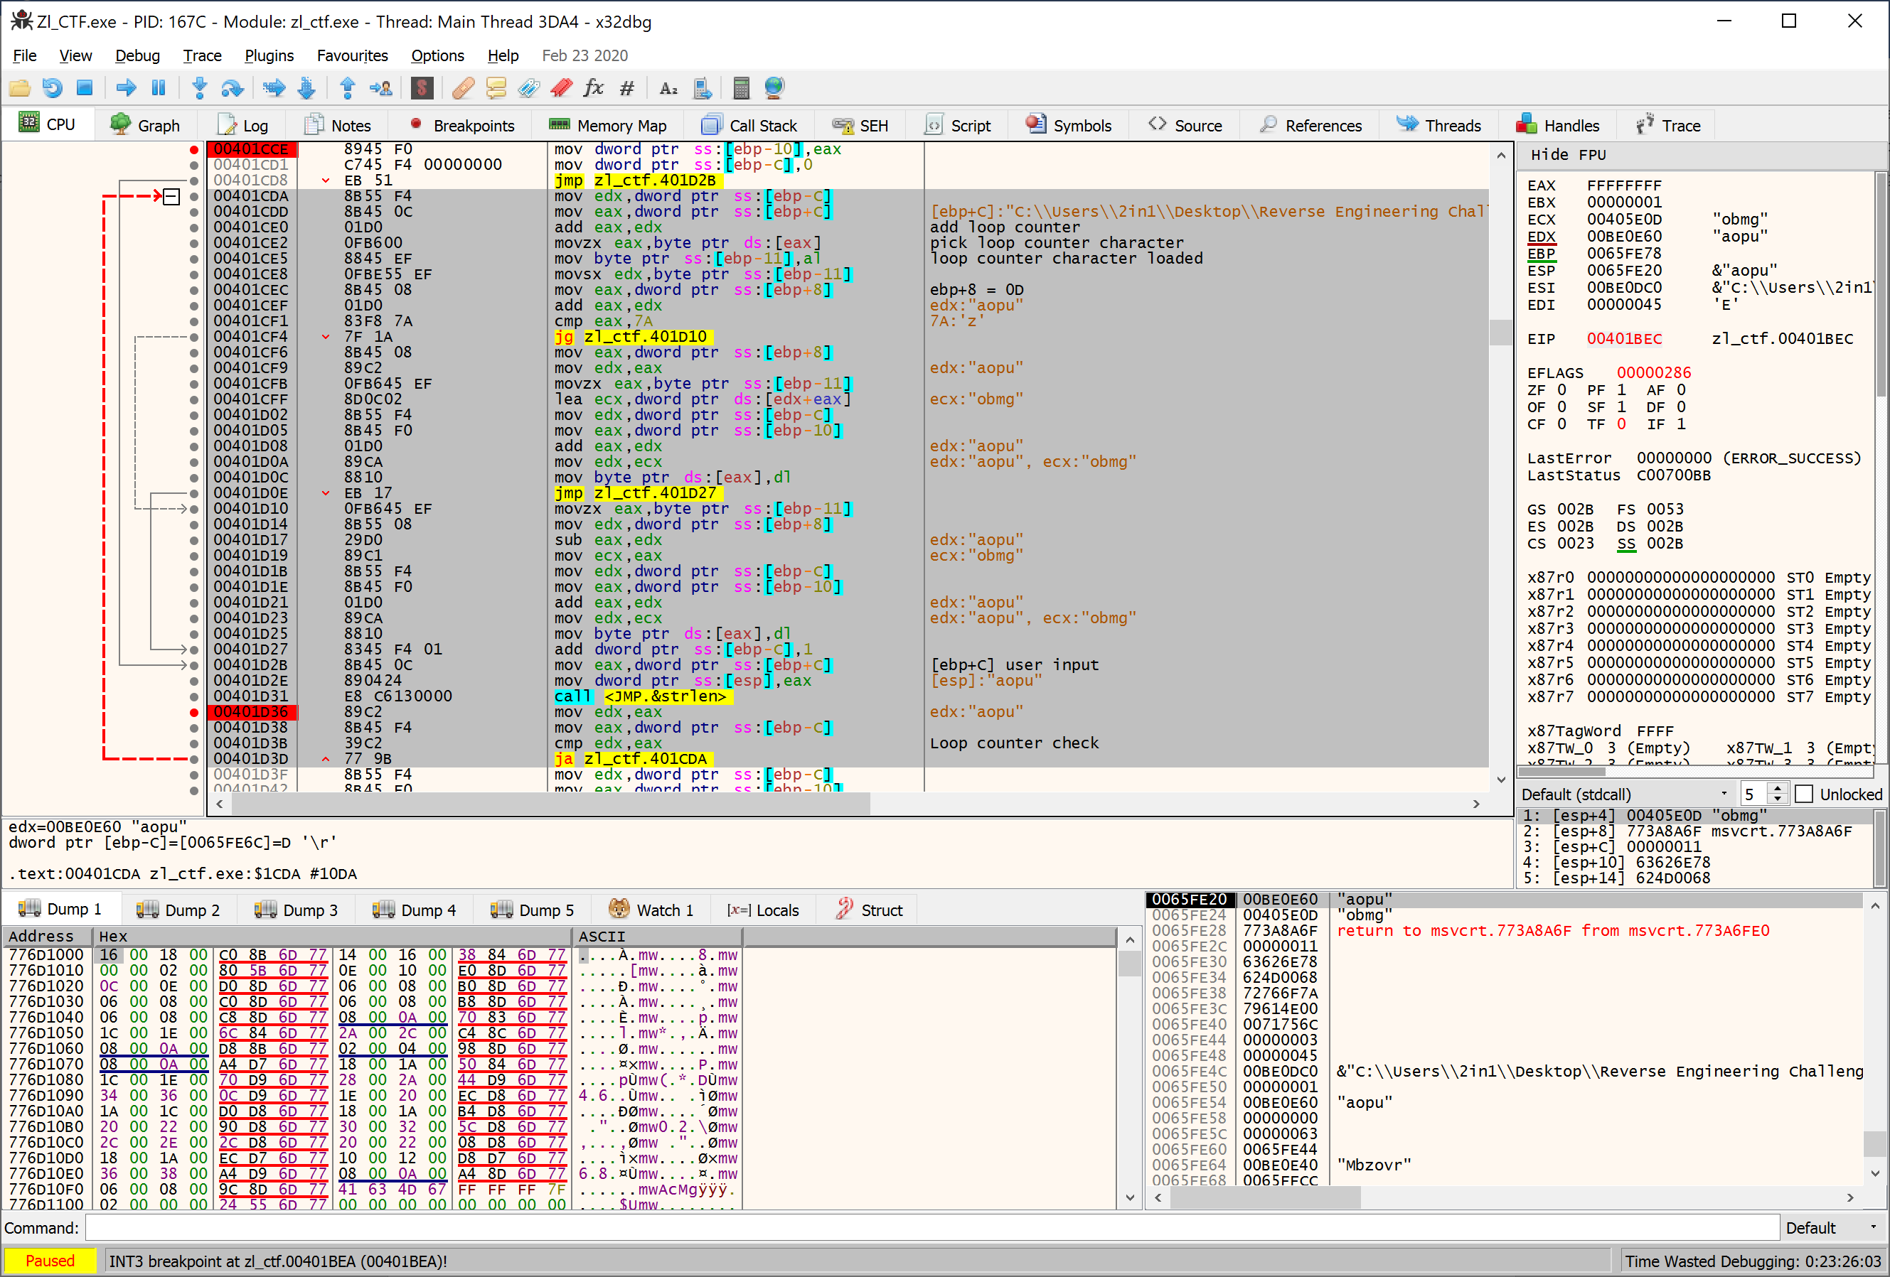

With this new found knowledge, we can very quickly go about reversing this loop to find the original input required by checking the hex code of the required input ‘obmg’ and adding/subtracting whether they are odd or even, because our input turns odd characters into even, therefore the required input needs to be the opposite.

|  |  |  |  |  |
| --- | --- | --- | --- | --- |
| Required | o | b | m | g |
| Hex Required | 6f (odd) | 62 (even) | 6d (odd) | 67 (odd) |
| Hex Input | 62 (even) | 6f (odd) | 7a (even) | 74 (even) |
| User Input | b | o | z | t |

After this, victory! We’re in! We get a message saying Zombieland and told we’re parting ways with our illusive (and seemingly useless!) counterpart. They donate a vehicle and we jump in… To become human happy meals?! Another challenge, and just like previously, we need to look at the Mbvour code, as it’s been read and transcribed into Zombieland, which leads us to forget rule 31, checking the backseat!...

We need to look at the compare just before the jump to see what we need. With everything input so far, the compare is checking esp+17 against S. Well when we look through what our esp+17 is, it’s s. This leads me to believe, much like the bangbang adaptation we did previously, that maybe we need to change an S of one of our previous challenge completions.

How I have struggled to find the exact code where it loads whether the user inputs S or s for (s)nowballs. After inputting Fnowballs, this leads me to believe that the reason we didn’t find the letter earlier is because it isn’t checked.

65fe97